# ORGANIZER INFORMATION

**COO PMH:** Michael Printup – [michael@parellamotorsports.com](mailto:michael@parellamotorsports.com)

**Communications:** SVRA: Ashleigh Aungst - [ashleigh@a2bstrategiesllc.com](mailto:ashleigh@a2bstrategiesllc.com)

Trans Am: Jessica Trippy – [jtrippy@gotransam.com](mailto:jtrippy@gotransam.com)

**Media:** Pam Shatraw – [pam@svra.com](mailto:pam@svra.com)

**Registration:** SVRA: Kathy Swinford – [kathy@svra.com](mailto:kathy@svra.com)

Trans Am: Kelley Huxtable – [registration@gotransam.com](mailto:registration@gotransam.com)

**Paddock:** SVRA: Alex Miller – [alex@svra.com](mailto:alex@svra.com)

Trans Am: Jeff Luckritz – [paddock@gotransam.com](mailto:paddock@gotransam.com)

**Series Admin:** SVRA: Alex Miller – [alex@svra.com](mailto:alex@svra.com)

Trans Am: Terry Ozment – [tozment@gotransam.com](mailto:tozment@gotransam.com)

# CIRCUIT DETAILS

**Circuit Information:** Michelin Raceway Road Atlanta, 5300 Winder Highway, Braselton, GA 30517 [www.roadatlanta.com](http://www.roadatlanta.com/) | 1-800-849-RACE

**Length of Circuit/Turns:** 2.54 miles, 12-turn road course

**Race Direction:** Clockwise

**Pole Position:** Drivers right

**Start & Finish Line:** Pit Straight

**Pit Lane Speed:** 40 mph. Determined by Pit Lane Speed Limit judges located in pit lane.

**Registration:** All participants must go to the Registration building to sign the track waivers after staging in the indicated location on the next page.

**Paddock Locations:** SVRA & IGT: Tower Paddock (outside)

Trans Am: Pro Paddock (inside)

**Grid Location:** SVRA: along Tower side pit lane, closest to T1

Trans Am: along Pro side pit lane, closest to T12

**Race Control Location:** Fourth floor of Michelin Tower

**Timing & Scoring:** Fourth floor of Michelin Tower

**Media:** Media Center in Tower – 2nd floor

**Stewards’ Office:** SVRA: Race Control

Trans Am: Series Trailer

**Meeting Location:** 2nd Floor Media Center in Tower

**Podium Ceremony:** SVRA: Tower pit lane, closest to T12

Trans Am: end of Pro paddock, closest to T12

**Black Flag Locations:** Turn 9 and Start/Finish

**Track PA & Broadcast:** 98.1 FM

**Track Security:** See Michelin Raceway Road Atlanta security at the main gate. Security will be provided from noon on Tuesday March 21st through the end of the event on Sunday.

**Pit Vehicle Policy:** Helmets must be worn when driving any pit vehicles outside of the paddocks, except golf carts.

**Camping:** Overnight camping is allowed. Tent camping is available.

**RVs:** RVs will not be allowed in the paddocks unless they are towing a trailer. A limited number of RV spots remain available in the Tower Paddock. Please contact Alex: [alex@svra.com](mailto:alex@svra.com) to secure a space.

**Camping Services:** Lightnin RVs: 770-963-9889

**Waste Disposal:** Tower Paddock: next to Fueling Station

Pro Paddock: along the back by the hill, about halfway between the entrance and exit roads

**Shipping Address:** Road Atlanta, c/o Team Name/Individual Name with cell, 5300 Winder Highway, Braselton, GA 30517

**Package Retrieval:** In Garages 10-12 in the Tower Paddock side; tower side.

**Pets:** Pets are allowed in the paddock and must be always kept on a leash. No pets allowed on grid or pit lane. Owners must clean up after pets.

**Concessions:** Paddock Grill in the Tower Paddock.

TBA Food Vendor in the Car Show area inside the track at the top of Pro Paddock.

**Facility Restrictions:** <https://www.roadatlanta.com/track-info/policies>

**Track Emergency:** During Event: See ALS ambulance on site near pit lane

After Hours: Dial 911

# CIRCUIT DETAILS (continued):

**Nearest Hospital:** Northeast Georgia Medical Center Braselton, 1400 River Place, Braselton, GA 30517, 770-848-8000

**Level 1 Trauma Hospital:** Northeast Georgia Medical Center Gainesville, 743 Spring Street NE, Gainesville, GA 30501, 770-219-9000

# PADDOCK INFORMATION

**Staging Location:** Everyone will enter the facility through Gate 1.

SVRA: Use the 3 LEFT staging lanes

IGT: Use the 3 RIGHT staging lanes

Trans Am: On the hill above the Trans Am Paddock

**Staging Times:** SVRA: Wednesday, March 20 at 9:00 a.m.

IGT: Wednesday, March 20 at 9:00 a.m.

Trans Am: Wednesday, March 20 at 12:00 p.m.

**Load In Begins:** SVRA: Wednesday, March 20 1:00 p.m.

IGT: Wednesday, March 20 1:00 p.m.

Trans Am: Wednesday, March 20 3:00 p.m.

**Load Out:** Sunday, March 24 at 8 p.m. Trucks stage in the grassy lot by registration until 8:00 AM Monday morning, but all vehicles must clear the paddocks Sunday night.

**Concrete Blocks:** Concrete blocks are available from Michelin Raceway Road Atlanta for your canopies. There is a fee, and they must be reserved in advance. Details TBD

**Quiet Hours:** No race engines between 8:00 pm and 7:45 am each day, plus **Sunday from 10 a.m. to 12 p.m.**

***NO EXCEPTIONS***

**Paddock Space:** Georgia law requires each entrant to have a fire bottle with a minimum rating of 10ABC displayed in their paddock area.

**Cleanliness:** It is the responsibility of each competitor and team to always keep their paddock free of debris. All teams are expected to present the best possible image to both the fans and to the track.

**Paddock Power:** There are limited power spaces throughout the paddock areas. Series trailers and vendors will be given priority access to power.

**Personal Vehicles:** No personal vehicles are allowed in the paddock unless you used it to tow your trailer. All street cars must be parked in designated “STREET CAR PARKING” areas. Those taking their tow vehicle in and out of the paddock, please use caution and observe all fire lanes.

**Traffic Flow:** The Pro Paddock will have a strict one-way traffic flow (counterclockwise).

# COMPETITOR INFORMATION

**Truck Wash:** North Georgia Pressure & Soft WashSlade Westbrook 678-858-0955

**Nitrogen:** Airgas: Nicole Ciano 770-539-3267 or [nicole.ciano@airgas.com](mailto:nicole.ciano@airgas.com)

**Golf Cart Rentals:** Custom Golf Carts: Ken/Betty Billick 678-447-1475 or [download form here](https://drive.google.com/file/d/1IsIksHUfnhVAet7ZPwmI_Cw1gbovn8RJ/view?usp=sharing)

Golf Carts stickers are required for all golf carts. They can be obtained at Registration for $70. No special insurance forms are required.

**Event Pit Lane Access:** Must have a hot credential. Shorts are approved on Pit Lane for this event only during non-enduro sessions.

**Fuel:** Sunoco, the official racing fuel for SpeedTour events, will be available in both paddocks. Sunoco will be set up at the pumps in the Tower Paddock and along the back of the Pro Paddock, by the hill, about halfway between the entrance and exit roads.

**Fueling Hours:** Thursday-Sunday: 7:00 am to 3:00 pm

**Track Walk:** Track walks will be available Friday evening after track activity has completed. Listen to the PA for additional information.

**Spectator Information:** <https://www.roadatlanta.com/fan-guide/information/faqs>

**Live Stream:** This SpeedTour event will be live streamed and available for FREE on social media and online at the [SpeedTour.TV](http://www.speedtour.tv/) website. Streams of the SVRA events will be available on SVRA’s [Facebook](http://www.facebook.com/svralife) and [YouTube](http://www.youtube.com/svralife) pages, while Trans Am events will be available on the Trans Am [Facebook](http://www.facebook.com/gotransam) or [YouTube](http://www.youtube.com/thetransamseries) page. In addition, the full schedule (including IGT events) can be watched on [SpeedTour.TV](http://www.speedtour.tv/) or [YouTube.com/SpeedTourTV.](http://www.youtube.com/SpeedTourTV) A full streaming schedule will be available closer to the event.

**PADDOCK OVERVIEW MAP**

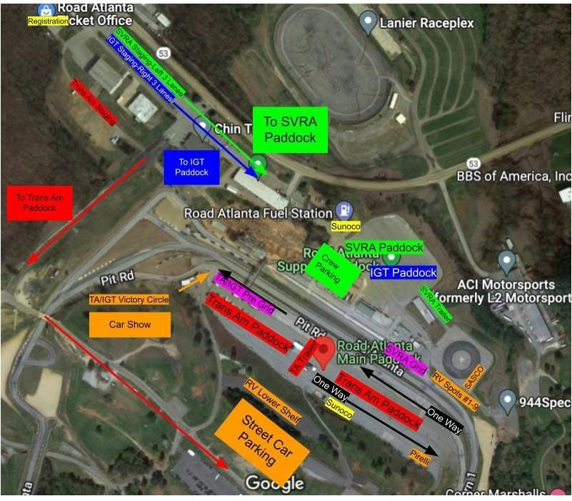

**TRACK MAP**

